WELCOME TO FIRST5
NETWORKING & SOCIAL EVENT

Please join us onboard the ‘Spirit of Plymouth’
Saturday 7 March 2019
Commercial Wharf, Barbican Landing Stage, PL1 2LR

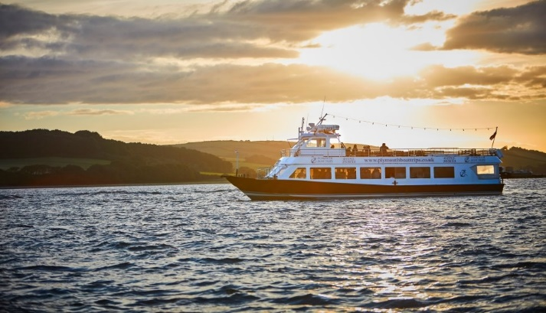

Registration from 12.00pm
Boat departs at 12:30pm
Returns at 15:00pm

Registration essential via the Tamar Faculty website

Contact Alice Sefton, Tamar Faculty Administrator for more information, tamar@rcgp.org.uk, 01392 722 744




